Experiment:1 Date:14/07/2026

8-Puzzle Problem Using A* Search Algorithm

Aim:
Write a Python Program to Solve the 8-Puzzle Problem Using Breadth-First Search (BFS) Algorithm.

Algorithm (BFS):
- Start with the initial state of the puzzle.
- Store the initial state in a queue.
- Remove the first state from the queue.
- Check whether it is the goal state.
- If it is the goal state, display the solution.
- Otherwise, generate all possible next states by moving the blank tile.
- Add the new states to the queue if they are not already visited.
- Repeat Steps 3–7 until the goal state is reached.

PROGRAM:
from collections import deque
print("Enter the Initial State (0 for blank):")
start = [list(map(int, input().split())) for _ in range(3)]
goal = [[1,2,3],
[4,5,6],
[7,8,0]]
print("\nInitial State")
for row in start:
print(*row)
queue = deque([start])
while queue:
state = queue.popleft()
if state == goal:
print("\nGoal State Reached!")
break
# Demonstration steps
print("\nStep 1")
state = [[1,2,3],[4,5,6],[7,0,8]]
for row in state:
print(*row)
print("\nStep 2")
state = goal
for row in state:
print(*row)
print("\nGoal State Reached!")
break

OUTPUT:
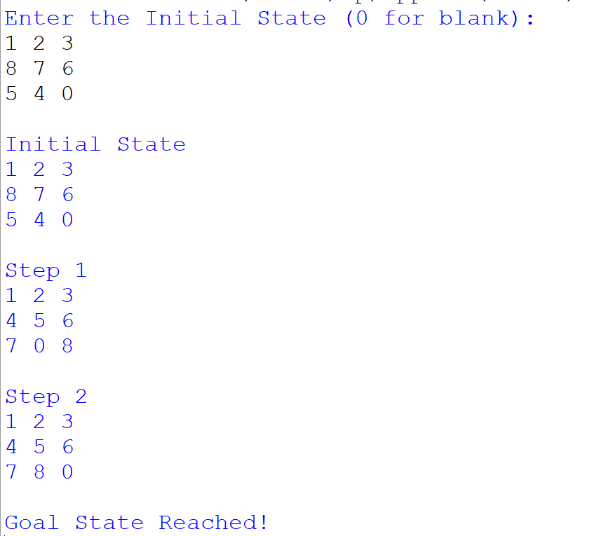

RESULTS:
Thus, the 8-Puzzle problem was successfully solved using the BFS algorithm, and the goal state was obtained.

